The Unhomely: Explorations of Diaspora, Displacement, Belonging and Identity

Open Call: Student Responses to Documentary Screening

Fee: £250 bursary

Aim of the Project

Culture& is an Arts Council England supported organisation based at the University of Staffordshire. The Unhomely public programme aims to examine how histories of migration, displacement, belonging, and Identity shape both personal and collective understandings of home. Through art exhibitions, interventions, events, and creative research, the programme seeks to create a space where artists, curators, and communities can explore what it means to live between worlds where the familiar becomes strange, and the past continues to echo within the present. Culture& invites students attending The Unhomely documentary screening on Wednesday 11 March 2026 at the University of Staffordshire Film Theatre to submit a visual interpretation and/or written review responding to the two films being screened:
- You Hide Me Nii Kwate Owoo (1970) 17 mins
- Dahomey Mati Diop (2024) 68 mins
This call is open to students across Creative Industries disciplines, including Fine Art, Fashion, Graphic Design, Film, and related courses.

What we’re looking for

We are inviting thoughtful, creative responses that engage with the core themes of The Unhomely, including:
- The uncanny when the familiar becomes strange
- Home, displacement, migration and belonging
- Archives, restitution and cultural memory
- What it means to “return” objects, histories, or people

Submissions can take the form of:
- A written review or critical reflection
- A visual response (illustration, collage, photography, graphic work, mixed media)
- A hybrid approach combining text and image

This opportunity offers students a chance to contribute to a major public arts programme, gain visibility for their work, and be part of a wider conversation around culture, memory and belonging. For further information, please visit Culture& platforms or contact info@cultureand.org

Selected submissions

- Two submissions will be selected
- Each selected student will receive a £250 bursary
- Selected works will be:
  - Featured on the Culture& website and social media channels
  - Used in promotional material for The Unhomely screenings and events at The Brampton Museum (September–December 2026)

How to submit
Students can submit their work in one of two ways:
1. In-gallery submission (participatory space)
A dedicated participatory area will be available in the Henrion Gallery at University of Staffordshire from 9 March – Thursday 16 April 2026.
Students are encouraged to use this space creatively to develop and submit their response.
2. Email submission
Send your entry to: info@cultureand.org with your university email
Please include:
- ‘Responses to Documentary 2026’ as the email subject line
- Your name and course
- A short statement about your response (max 300 words)
- Your submission (written or visual work). Please do not send a link that expires. Thank you.

Key dates
- Participatory space (Henrion Gallery) open: 9 March - Thursday 16 April 2026
- Double-bill Screening & Panel Discussion: Wednesday 11 March 2026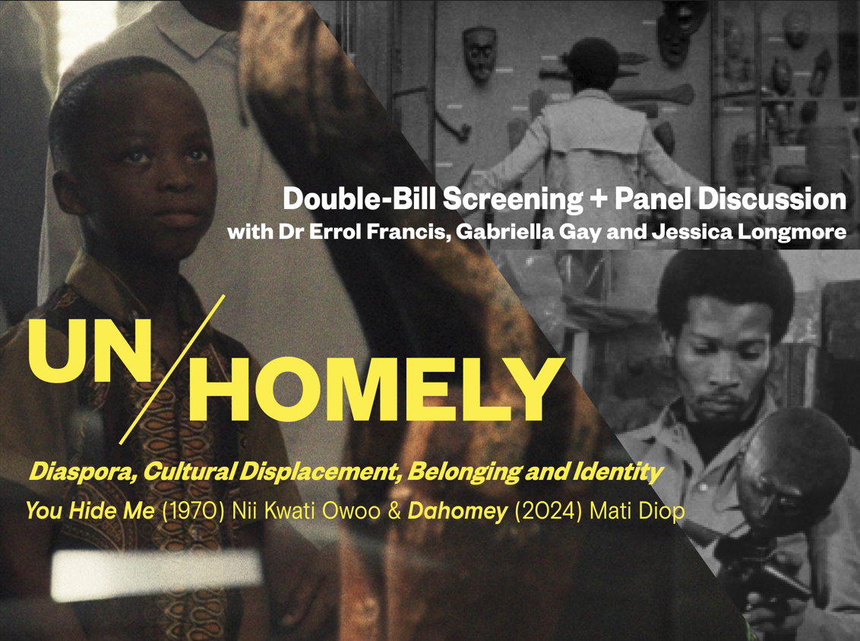
- Submission deadline: Thursday 16 April 2026
- Selected contributors notified: Start of Easter Term

